**System Requirements Specification**

**for**

**Portable Ultrasound Device for Coda-Wave Interferometry**

**Version 1.0**

**Prepared by Michael Kisellus**

**Christopher Coppedge**

**Layton Foxworthy**

**Matthew Baker**

**Kyle Fox**

**27OCT2023**

**Table of Contents**

**Table of Contents ii**

**Revision History ii**

**1. Introduction 4**

1.1 Purpose 4

1.2 Document Conventions 4

1.3 Intended Audience and Reading Suggestions 4

1.4 Product Scope 4

1.5 References 5

**2. Overall Description 5**

2.1 Product Perspective 5

2.2 Product Functions 6

2.3 User Classes and Characteristics 6

2.4 Operating Environment 7

2.5 Design and Implementation Constraints 7

2.6 User Documentation 7

2.7 Assumptions and Dependencies 8

**3. External Interface Requirements 8**

3.1 User Interfaces 8

3.2 Hardware Interfaces 10

3.3 Software Interfaces 10

3.4 Communications Interfaces 10

**4. System Features 11**

4.1 System test pulse generation and reception 11

4.2 System self-regulation/ protection for overheat 12

4.3 System alarm system 12

4.4 After test processing 13

**5. Other Nonfunctional Requirements 14**

5.1 Performance Requirements 14

5.2 Safety Requirements 14

5.3 Security Requirements 14

5.4 System Quality Attributes 14

5.5 Business Rules 14

**6. Other Requirements 15**

**Appendix A: Glossary 15**

**Appendix B: Analysis Models 15**

**Appendix C: Reference 17**

**Appendix D: To Be Determined List**

**Revision History**

| **Name** | **Date** | **Reason For Changes** | **Version** |
| --- | --- | --- | --- |
| Michael Kisellus | 22 SEP | Initial draft | 1.0 |
| Matthew Baker | 29 Sep | Editing and Proofreading prior to turn-in | 1.1 |
| Michael Kisellus | 24 Oct | Editing | 2.0 |
| Michael Kisellus | 27 Oct | Revise figure 1 and 2 | 2.1 |
|  |  |  |  |

# **Introduction**

This product is designed to output a 500v 2µsec pulse to a transducer. This transducer then emits waves which travel through a concrete test sample and are absorbed by a second transducer producing an electrical signal which returns to the test unit. The returned signal is recorded and saved to a removable memory device. The saved data is then taken and processed in a computer to display the data and determine if faults are present within the tested concrete.

## **Purpose**

This document intends to define all requirements and conditions relating to the Portable Ultrasound Device. This document covers the physical device hardware, software required to operate the device, operator interaction with the device and the requirements used to produce the unit. As well as software used to process the data collected by the unit (if applicable).

This document was produced on 22 SEP 2023. As of this document date the most Current revision is 1.1. This is the finalized V1 draft for turn-in on 29 SEP 2023.

## Document Conventions

Document is in keeping with the provided template, no other requirements exist for this document specific to this project.

## **Intended Audience and Reading Suggestions**

The intended user for this product is civil engineers and maintenance workers responsible for the integrity of bridge support pillars. This also applies for any profession working with or testing load bearing concrete support pillars such as inspectors or safety personnel. This document contains information on product functionality and requirements given by the client Dr. Brown. Section 2 contains an overall view of the project. Section 3 contains information and procedures for how to use the product. This would be most useful to a system operator or troubleshooter. Section 4 and 5 contain features and operational requirements for the system.

Section 1.4 contains any references used and is required to fully understand or troubleshoot the device.

## **Product Scope**

The infrastructure within America is aging and this includes the bridge infrastructure. As load bearing concrete is placed under stress micro cracks propagate and may not be visible on the surface. This crack weakens the overall structure and will eventually lead to the failure of the bridges supporting pillars. Risking the lives of all the users of that infrastructure. Currently inspectors perform visual inspections to predict the failure of bridge support pillars.

The goal of this system is to provide bridge maintenance and safety workers with a field service tool to detect crack propagation. This will allow the operator to gather data over the course of 72 hours and make a more accurate determination of the bridged pillars structural integrity and therefore make the bridge safer for all its users.

The project is to produce this rugged field service unit which after being placed to measure a concrete section will collect data over the course of 48 to 72 hours and be retrieved to review the collected data. The unit will be light enough for one person to move, weather resistant and durable enough for field work.

## **References**

Appendix C contains the references used for the PUD project.

# **Overall Description**

Section 2 covers the project's purpose is section 2.1, product functions in section 2.2, user information in section 2.3, and description of the operating environment in section 2.4. Sections 5,6, and 7 contain constraints, user documentation and assumptions made for the unit.

## **Product Perspective**

The Portable Ultrasound Device for Coda-Wave Interferometry is a new, self-contained product that assists in the internal inspection of concrete support pillars. The system consists of a standalone unit for measuring and recording a concrete sample response to a transducer generated wave.

Figure 1: overall system diagram for portable ultrasound device (PUD)

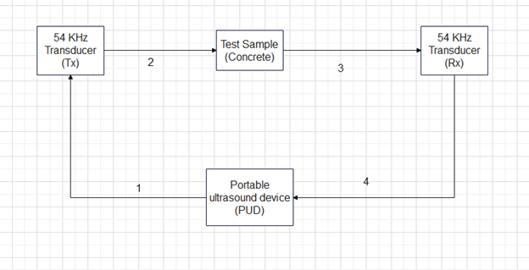

Figure 2: Portable ultrasound device(PUD) hardware diagram

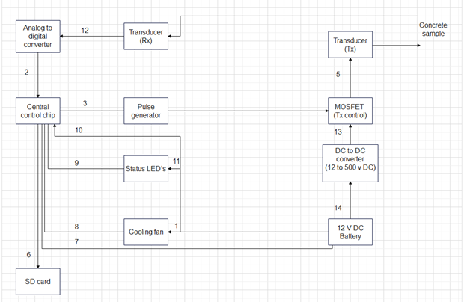

## **Product Functions**

### Generate a test pulse to the transistor transmitter (TX).

### Receive response signal from the transistor receiver (Rx)

### Store the received data locally (SD card)

### Process raw data offsite using computer programs.

**2.2.5** Monitor and maintain device functionality for an extended period of time.

## **User Classes and Characteristics**

### **Data analyst**

The Data analyst will receive the raw data from the unit and through the use of various computer programs will interpret the results. Making the determination if there is interior structural damage. If the results are inconclusive then the data analyst can request the test engineer to take another sample or reposition the test transducer positions.

### **Test engineer**

The test engineer will be responsible for going into the field and performing transducer placement to perform the test. Activating the unit to collect data. Then retrieving the unit 48 to 72 hours after test initiation.

## **Operating Environment**

### **User interface**

The user will interface with the device through a panel of switches. They will have corresponding LEDs to ensure the user their input was registered. Because the interface is physical it will require no exterior programs to function during testing.

### **Data processing**

The data saved during testing is saved on a Sd card using .mat format (other formats may be considered but currently the civil engineering lab is using .mat). Requiring the user to possess a window 10 or later operating software. Python, possibly C (if lower level coding is required) and MATLAB programs are required to operate the analysis software.

## **Design and Implementation Constraints**

### Design constraints

* The unit shall not exceed 25 pounds.
* The unit shall be similar or smaller in size to that of a suitcase.
* The unit budget shall not exceed $2000.
* The unit battery shall last for 48-72 hours or greater with samples being taken every 10 min.
* The unit shall have minimum data storage of 32 GB.
* The unit shall not exceed operating temperatures of 140° F.

**2.5.2** Implementation constraints

* The unit shall provide a Transmitter output pulse of 500V for 2µsec to the transducer.

## **User Documentation**

The following documents are the required documentation to operate the PUD.

### Users guide for PUD system.

### PUD system troubleshooting guide.

**2.6.3** PUD Analysis software tutorial guide.

## **Assumptions and Dependencies**

**2.7.1** Ambient temperatures during operation do not exceed 100° F.

**2.7.2** The battery is fully charged before sampling starts.

**2.7.3** The battery is in good condition and has not degraded from age.

**2.7.4** The unit is placed in a dry location protected from major weather interference.

**2.7.5** The unit is not disturbed by unauthorized personnel during testing/ random passerby.

**2.7.6** The unit is used following the user manual.

**2.7.7** The user places the transistor transmitter and receiver correctly.

**2.7.8** The unit has no component failures.

**2.7.9** The user has a working laptop with Thonny and MATLAB installed.

# **External Interface Requirements**

Section 3 contains information regarding the user interface. This includes hardware and software interfaces. Section 3.1 ,3.2 and 3.3 cover the user, hardware and software interfaces. Section 3.4 covers the communication interface.

## **User Interfaces**

The user interface for the PUD is placed on the exterior of the unit and is designed to be extremely simple to operate for the user. Utilizing push buttons to start or stop the testing sequence. Then using software on a separate computer to analyze the data collected. Below is the operational procedure for users.

### Turn on the unit's main power switch.

### Verify power available light on. Shown on figure 3.

### Verify no lights are illuminated in the alarm section. Shown on figure 3.

### Select 10min, 6hr, 12hr, 24hr, 48hr, or 72hr testing time setting. Shown on figure 3.

### Verify selected time setting indicating light is lit for selected time Shown on figure 3.

### Press the start test button. Shown on figure 3.

### Verify the test running status light is on. Shown on figure 3.

### Wait for the test finished light to illuminate or select stop and save button to stop test early.

### Turn off the main power switch.

### Remove the memory storage SD card. Shown on figure 3.

### Place the SD card into the computer used for analysis.

Figure 3: Draft of front panel for PUD

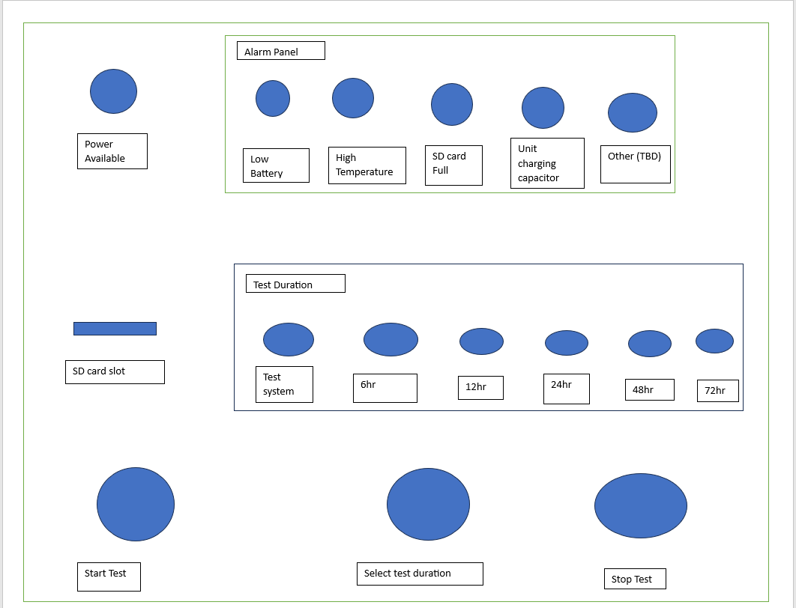

## **Hardware Interfaces**

The PUD hardware has several input commands given by pushbuttons to interface with the Raspberry Pi pico which controls the testing procedure and writes the results to a removable hardware storage device (SD card). Which then interacts with Matlab (similar to file format this is subject to change) to produce the desired result.

### The push buttons shall input commands to the Raspberry Pi

### The Raspberry Pi Pico shall send a switching signal to the MOSFET to gate the 500v input on and off.

### The Raspberry Pi Pico shall send PWM or digital switching signals to the cooling fan to control its speed and on/off status.

### The Raspberry Pi Pico shall send commands to the status and alarm LEDs to turn on or off

### The ADC chip shall receive inputs from the transducer receiver.

### The Raspberry Pi Pico shall send commands to the SD card to record the received signal.

### The SD card will store data and be kept in a computer and matlab readable format.

**3.2.8** A laptop separate from the PUD shall run the Matlab software required to analyze the raw data.

## **Software Interfaces**

The PUD system has one operating software system running on a Raspberry Pi pico unit. Then later in the process a laptop running Matlab is used to process the data retrieved from the test.

### The PUD shall use a Raspberry Pi pico.

### Raw data from the receiving transducer shall be sent to SD card using .mat format.

### Laptop using Matlab shall retrieve data from SD card.

### Laptop shall be running Windows 10 or later.

**3.3.5** Laptop shall have Thonny and MATLAB installed.

## **Communications Interfaces**

*<Describe the requirements associated with any communications functions required by this product, including e-mail, web browser, network server communications protocols, electronic forms, and so on. Define any pertinent message formatting. Identify any communication standards that will be used, such as FTP or HTTP. Specify any communication security or encryption issues, data transfer rates, and synchronization mechanisms.>*

This section does not strongly apply to this unit as it does not contain any form of inter-device communications in a wireless form. However there are two common communication interfaces for the hardware. This consists of the SPI bus and a UART system.

3.4.1 The Raspberry Pi Pico will use the SPI bus to move data between internal components.

3.4.2 The Raspberry Pi Pico will use the UART system to allow for programming and system updates.

# **System Features**

Section 4 provides amplifying information on the system functions discussed in section 2.2.

## **System test pulse generation and reception**

4.1.1 Description and Priority

The PUD system’s main function is to provide the transducer with the pulse required to generate a testing frequency which propagates through the test material and is received by a second receiving transducer and returned as a voltage to the system and recorded. High

4.1.2 Stimulus/Response Sequences

After the user powers on the unit and selects a test duration, then the start test button is pressed.

The unit will then save results to the SD card over the course of the test duration. Which the user can then take after the test completes or the user stops the test early.

4.1.3 Functional Requirements

4.1.3.1 The electrical system shall produce 500 V 2µsec test pulse.

4.1.3.2 The control system shall be able to gate the test signal on and off within 2µsec (MOSFET)

4.1.3.3 The system shall be able to produce 50 test signals with 100µsec interval between the test pulses.

4.1.3.4 The system shall convert the analog signal received from the receiver transducer into a digital signal which can be recorded.

4.1.3.5 The system shall be able to save the data received from the receiving transducer to a SD card.

4.1.3.6 The system shall have greater than or equal to 35 GB of storage space to store test data.

## **System self-regulation/ protection for overheat**

4.2.1 Description and Priority

The PUD system performs self-monitoring of its internal temperature and activates the cooling systems to protect itself from entering failure conditions(131-140°F depending on the component). Shutting down if unable to correct the issue within 5 min to protect the system.

4.2.2 Stimulus/Response Sequences

No operator action required.

The internal temperature is detected to be approaching 131°F. This triggers the cooling fan to activate at a rate of revolutions per minute in accordance with a pre-programmed hysteresis curve (as seen in Figure 4) and cool the unit with ambient air from the unit’s surroundings.

4.2.3 Functional Requirements

4.2.3.1 The system shall be able to monitor internal temperatures within the unit.

4.2.3.2 The system shall run the cooling fan via pulse-width modulation in accordance with a pre-programmed hysteresis curve.

4.2.3.3 The system shall shut down in the event that temperatures cannot be reduced below the danger level.

## **System alarm system**

4.3.1 Description and Priority

The system shall monitor for various failure conditions and alert the user to any detected abnormalities. This includes overtemperature, SD card full, and low battery. Low

4.3.2 Stimulus/Response Sequences

No user input required

Overheat, SD card Full, or low battery event occurs.

The system will illuminate a LED on the alarm panel to alert the user.

4.3.3 Functional Requirements

4.3.3.1 The system shall be able to monitor internal unit temperature.

4.3.3.2 The system shall turn power on for the overheated LED on the alarm panel if temperature exceeds or is equal to 125°F for more than 1 min.

4.3.3.3 The system shall shut down if temperature exceeds or is equal to 130°F for more than 30 seconds..

4.3.3.4 The system shall be able to monitor SD card status.

4.3.3.4.1 The system shall power on if no SD card is inserted and flash the “SD Card Full” and “Power” LEDs if the card is not present.

4.3.3.4.2 If no SD card is present, the machine shall not perform the test phase.

4.3.3.5 The system shall turn power on for the SD card full LED on the alarm panel if the SD card is 95% of max storage capacity.

4.3.3.6 The system shall record over the oldest data on the SD card if the error is not corrected.

4.3.3.7 The system shall be able to monitor battery voltage.

4.3.3.8 The system shall turn power on for the low battery LED on the alarm panel if the battery voltage drops to or below 10.5V

4.3.3.9 The system shall turn off the system if battery voltage is below 10V for greater than 1 min.

## **After test processing**

4.4.1 Description and Priority

The programs used to process the data retrieved from the PUD unit SD card. Making the raw data useful and displaying it in a useful format for analysis.

4.4.2 Stimulus/Response Sequences

Sd card is placed in laptop used for processing and analyzed using Matlab

4.4.3 Functional Requirements

4.4.3.1 SD Card slot shall be protected by an external cover that requires external action to open

4.4.3.2 SD Card shall contain a locking latch mechanism

4.4.3.3 SD Card slot shall present an alignment guide to ensure proper insertion

# **Other Nonfunctional Requirements**

Section 5 consists of requirements and regulations other than the ones stated in previous sections.

## **Performance Requirements**

5.1.1 The system shall operate for 48 to 72 hours without recharging the internal battery

5.1.2 The system shall have fans and thermal monitoring to ensure components do not overheat IAW applicable component requirements.

## **Safety Requirements**

### The system shall have an external safety lock to protect the user from high voltages present within.

### The system shall have a warning posted on the outside to alert the user to secure power and wait 40 minutes prior to opening due to risk of shock from high voltage supply and capacitor bank.

5.2.3 The safety lock shall be electrically isolated from any of the high voltage components to prevent shock.

## **Security Requirements**

The project has no security requirements as the data is not sensitive or private.

## **System Quality Attributes**

### All system components shall be tested prior to installation

### The system when fully constructed shall be tested using a test plan.

**5.4.3** A parts list shall be provided along with the finished product to the user.

## **Business Rules**

**5.5.1** Only personnel who have read the operating manual should operate the equipment.

# **Other Requirements**

*<Define any other requirements not covered elsewhere in the SRS. This might include database requirements, internationalization requirements, legal requirements, reuse objectives for the project, and so on. Add any new sections that are pertinent to the project.>*

## The case shall be able to withstand a fall from 3 ft and protect the contents of the case

**6.2** The case shall be water resistant and be able to protect the contents from water penetration from rain

6.3 The electrical distribution system shall not exceed a component's rated limits, as shown in its related datasheet.

6.4 The electrical system shall have no faulty components.

6.5 The electrical system shall produce 5,12, and 500V DC.

6.6 The electrical system shall have sheathing protection.

6.7 The electrical system components shall be securely mounted to the casing.

6.8 The electrical system shall have no unintended paths to ground.

**Appendix A: Glossary**

LED – Light emitting diode

MOSFET-Metal-oxide-semiconductor field-effect transistor

PUD-Portable Ultrasound Device

Rx- Receiver

Tx- Transmitter

SD-Secure Digital card

**Appendix B: Analysis Models**

*<Optionally, include any pertinent analysis models, such as data flow diagrams, class diagrams, state-transition diagrams, or entity-relationship diagrams*.>

Figure 4: Cooling fan behavior vs temperature

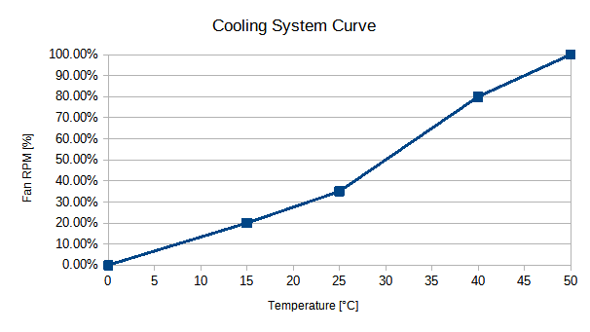

Figure 5: Electrical system schematic diagram

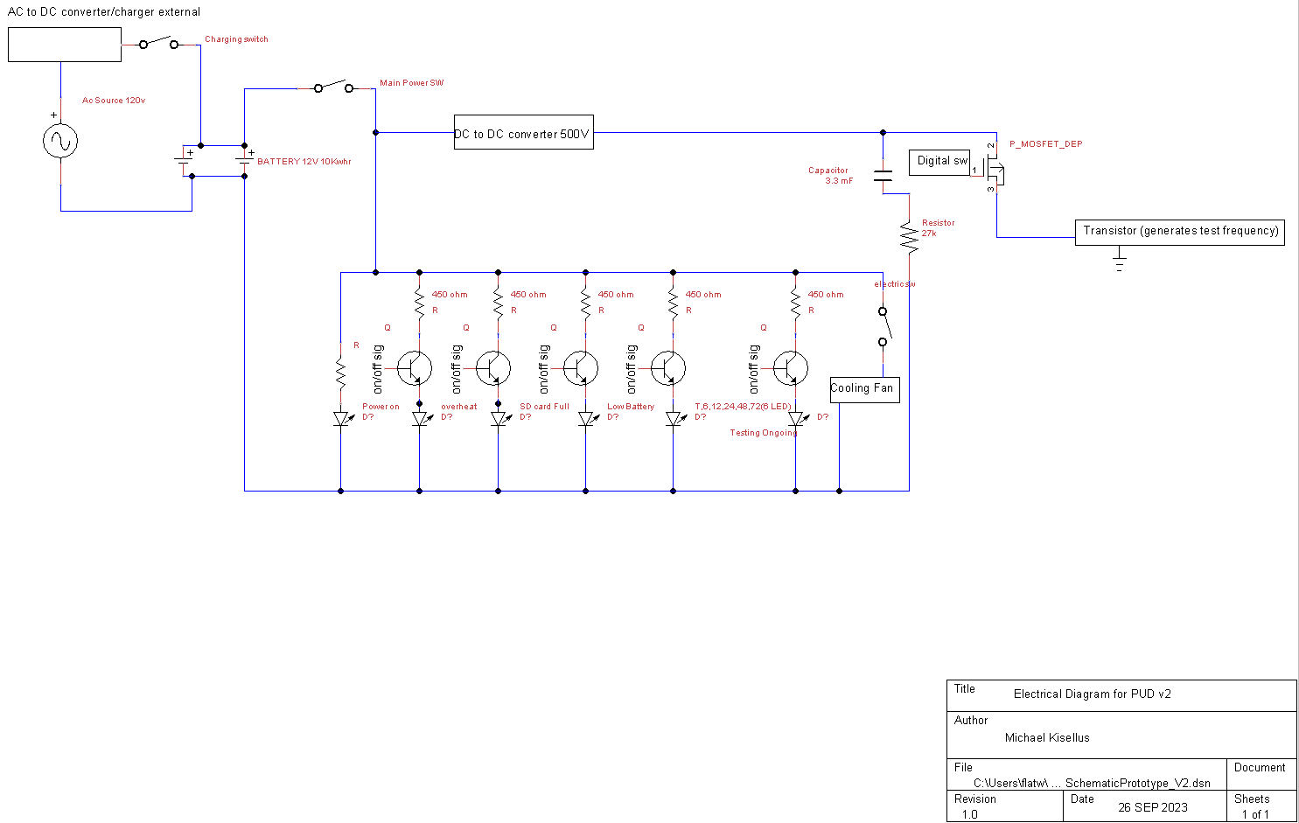

**Appendix C: Reference**

“021706.3TXP Littelfuse Inc. | Circuit Protection | DigiKey.” *DigiKey*, www.digikey.com/en/products/detail/littelfuse-inc/021706-3TXP/3425317. Accessed 21 Oct. 2023.

“05200005ZXGY Littelfuse Inc. | Circuit Protection | DigiKey.” *DigiKey*, www.digikey.com/en/products/detail/littelfuse-inc/05200005ZXGY/554334. Accessed 21 Oct. 2023.

“0ADKC5000-Be Bel Fuse Inc. | Circuit Protection | Digikey.” *DigiKey*, www.digikey.com/en/products/detail/bel-fuse-inc/0ADKC5000-BE/7404459. Accessed 21 Oct. 2023.

“100ft - 1/2 Inch Pet Expandable Braided Sleeving - Amazon.Com.” *Amazon*, www.amazon.com/100ft-Expandable-Braided-Sleeving-braided/dp/B074GMNW7T. Accessed 21 Oct. 2023.

“12-48V Battery Isolator Switch for Car Vehicle RV and Marine (on/off): Eco-Worthy.” *ECO*, www.eco-worthy.com/products/12-48v-battery-isolator-switch-for-car-vehicle-rv-and-marine-on-off?variant=40589578567868. Accessed 21 Oct. 2023.

“2-1546306-1 TE Connectivity AMP Connectors - DigiKey Electronics.” *DigiKey*, www.digikey.com/en/products/detail/te-connectivity-amp-connectors/2-1546306-1/1136667. Accessed 21 Oct. 2023.

“330 PCS M2 Male Female Brass Hex Spacer Standoffs Screws ... - Amazon.Com.” *Amazon*, www.amazon.com/Standoffs-Assortment-Threaded-Circuit-Motherboard/dp/B0BZYTC581. Accessed 21 Oct. 2023.

“577002B00000G Aavid, Thermal Division of Boyd Corporation - Digikey.” *DigiKey*, www.digikey.com/en/products/detail/aavid-thermal-division-of-boyd-corporation/577002B00000G/102507. Accessed 21 Oct. 2023.

“5A 12V Automatic Smart Battery Charger and Maintainer with LCD Display for Lead Acid and Lithium (LiFePO4) Batteries: Eco-Worthy.” *ECO*, www.eco-worthy.com/products/5a-12v-automatic-smart-battery-charger-and-maintainer-with-lcd-display-for-lead-acid-and-lithium-lifepo4-batteries?variant=42350017052921. Accessed 21 Oct. 2023.

“6AWG (16mm2) 13 Inch Battery Interconnect Cable: Eco-Worthy.” *ECO*, www.eco-worthy.com/products/6awg-16mm-13-inch-battery-interconnect-cable?variant=34593133625509. Accessed 21 Oct. 2023.

“Als30a332np500 Kemet | Capacitors | Digikey - Digi-Key Electronics.” *Digikey*, www.digikey.com/en/products/detail/kemet/ALS30A332NP500/3462159. Accessed 21 Oct. 2023.

“Amazon.Com: XHF 3/4" Strong Back-Glue Self Adhesive Black Cable Zip Tie ...” *Amazon*, www.amazon.com/XHF-Back-Glue-Protection-Fasteners-Management/dp/B08F77YVYB. Accessed 21 Oct. 2023.

“ANCOR Marine Grade Primary Wire and Battery Cable - Amazon.Com.” *Amazon*, www.amazon.com/Ancor-Marine-Grade-Primary-Battery/dp/B07ZSDK651. Accessed 21 Oct. 2023.

“ANSI Z535 Safety Labels - Hazardous Voltage Inside.” *Seton*, www.seton.com/ansi-z535-safety-labels-hazardous-voltage-inside-l5476.html?utm_campaign=%5BNB%5D_Labels_Catch%2BAll_PLA-S_High_All_PC-02_GGL_SUS&utm_source=google&utm_medium=cpc&utm_term=&matchtype=&device=c&adgroupid=&gclsrc=aw.ds&gclid=CjwKCAjwseSoBhBXEiwA9iZtxo15KyzhNfMKE5oyzbC-vorhbGmpge9ewSppeK7ReCrhPLgh6Yt0NRoCVhcQAvD_BwE. Accessed 21 Oct. 2023.

“C503C-Wan-CCADB232 Creeled, Inc. | Optoelectronics | DigiKey.” *DigiKey*, www.digikey.com/en/products/detail/creeled-inc/C503C-WAN-CCADB232/2681196. Accessed 21 Oct. 2023.

“CF12JT390R Stackpole Electronics Inc | Resistors | Digikey.” *DigiKey*, www.digikey.com/en/products/detail/stackpole-electronics-inc/CF12JT390R/1741140. Accessed 21 Oct. 2023.

“DC 12V 24V to 5V Step down Converter Regulator 5A 25W Power Adapter ...” *Amazon*, www.amazon.com/Converter-Regulator-Adapter-Reducer-Electronics/dp/B07Q5W1BG3. Accessed 21 Oct. 2023.

“High Voltage Power Supply AHV12V500V20MAW Analog Technologies | Power ...” *DigiKey*, www.digikey.com/en/products/detail/analog-technologies/High-Voltage-Power-Supply-AHV12V500V20MAW/18621897. Accessed 21 Oct. 2023.

“LiFePO4 12V 50ah Lithium Iron Phosphate Battery: Eco-Worthy.” *ECO*, www.eco-worthy.com/products/lifepo4-12v-50ah-lithium-iron-phosphate-battery?currency=USD&variant=42491122712825&utm_medium=cpc&utm_source=google&utm_campaign=Google+Shopping&stkn=ac7b7d784bf0&gclid=CjwKCAjwgsqoBhBNEiwAwe5w02e_e41oUWis8aF0zZ64SqB2gfhDZQGvhFikRSAGGwQNgwVP8l8POBoCaacQAvD_BwE. Accessed 21 Oct. 2023.

“Miuzei PCB Board Prototype Kit for Electronic Projects, Circuit Solder ...” *Amazon*, www.amazon.com/Miuzei-Including-Prototype-Connector-Terminal/dp/B07PS4VCDD. Accessed 21 Oct. 2023.

“Ohmite Distributor | DigiKey Electronics.” *DigiKey*, www.digikey.com/en/supplier-centers/ohmite. Accessed 21 Oct. 2023.

“PMV16XNR Nexperia USA Inc. | Discrete Semiconductor Products | DigiKey.” *DigiKey*, www.digikey.com/en/products/detail/nexperia-usa-inc/PMV16XNR/5395791. Accessed 21 Oct. 2023.

“Ra-T2X-38E Ohmite | Fans, Thermal Management | DigiKey.” *DigiKey*, www.digikey.com/en/products/detail/ohmite/RA-T2X-38E/2416488. Accessed 21 Oct. 2023.

“SBBSM2106-1 Chip Quik Inc. | Prototyping, Fabrication Products | DigiKey.” *DigiKey*, www.digikey.com/en/products/detail/chip-quik-inc/SBBSM2106-1/5978238. Accessed 21 Oct. 2023.

“Starelo 5pcs 12mm Momentary Push Button Switch Black Shell with Pre ...” *Amazon*, www.amazon.com/Momentary-Push-Button-Switch-Without/dp/B09BKZ68HF. Accessed 21 Oct. 2023.

“STF19NM50N Stmicroelectronics | Discrete Semiconductor Products | DigiKey.” *DigiKey*, www.digikey.com/en/products/detail/stmicroelectronics/STF19NM50N/2346299. Accessed 21 Oct. 2023.

“TE120B2K7J Te Connectivity Passive Product | Resistors | DigiKey.” *DigiKey*, www.digikey.com/en/products/detail/te-connectivity-passive-product/TE120B2K7J/14308543. Accessed 21 Oct. 2023.

**Appendix D: To Be Determined List**

*<Collect a numbered list of the TBD (to be determined) references that remain in the SRS so they can be tracked to closure.>*